Test Case document Format -> **GroupName_QA01.xlsx or FnameLname_QA01.xlsx**

**QA Assignment 01 -> Write Test Cases**

**HCDP 2634 - UI : Login Module - Login with Location Functionality.**

**Description -> When Patient land on our Risk-Assist UI, User should have to provide login details.**

**Acceptance Criteria ->**

1. **User should able to add valid Username**
2. **User should able to add valid Password**
3. **User should have to select any one location from drop-down.**
4. **When user not select any location at that time one error text-box should be populated with error message as**

**“Location is required.”**

1. **The Max Characters accepted by Text-Boxes are 15 and Min is 05.**
2. **For Username text-box only alphabets should get accept.**
3. **For Password text-box alphanumeric should get accept.**

**Test Data -**

**Username - TestUser**

**Password - TestUser@123**

**Screenshot / Mock-Up ->**

**1)**

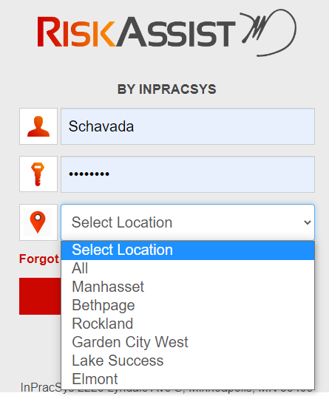

2)

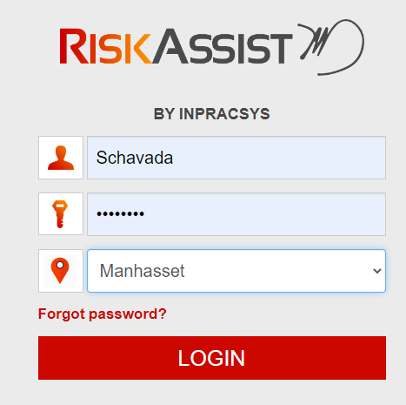

3)

